**BP315 Business Sub-Process Design Document**

**Customer Onboarding in CDC and Integration with Marketing**

**Cross Industry/Customer Insight and Growth**

**SAP – Cloud for Customer**

Table of Contents

1 Overview 3

1.1 Change History 3

1.2 RASCI 3

1.3 Approval Detail 3

1.4 Other Related Documents 4

2 Business Process Overview 4

2.1 High level requirements 5

2.2 Key Value Drivers for the Business Process 5

2.3 Leading Practice Inputs 6

3 Business Sub-Process Description 6

3.1 Business Sub-Process diagram 6

4 Sub Process Activities 6

4.1 Activity List 7

4.2 Inbound Communication 7

4.3 Outbound Communication 8

4.4 Test Conditions 8

5 Sub-Process Variation 8

5.1 Business Unit Led 8

5.2 Geography/Legal Entity Led 8

6 Role Definition & Organisational Impact 9

6.1 Role/Skill Class Inventory 9

6.2 Role Summary 9

6.3 Organizational Impact 9

7 Process Fitness & Gap Analysis 9

7.1 Process Fitness 9

7.2 Gap Analysis 10

8 RICEFW 10

8.1 Reports 10

8.2 Interfaces (Inbound / Outbound) 10

8.3 Conversions 11

8.4 Enhancements 11

8.5 Forms 12

8.6 Workflows 12

9 Integration Points 13

9.1 Integration Issues 13

9.2 Other issues 13

# Overview

Customer Data Cloud (CDC) is part of SAP customer experience portfolio which is used to identify & engage with customers in a secure environment. It simplifies their journey and protect them and their business from risk.

SAP customer identity provides seamless and secure access to customers through registration and social login screens. It gathers valuable data based on permission to drive more personalized customer experience while protecting their personal data. It facilitates improved omnichannel strategies with single sign-on, SAML 2.0, and open ID connect data federation standards and risk-based, multifactor, and password-less authentication options. It protects customers and business with network-protected identity feature, account harvesting detection and specialized protection against account takeover and DDOS attacks*.*

Technologies used in building this scenario are:

* SAP Customer Data Cloud
* SAP CPI
* SAP Marketing On-Premise
* SAP Web-Ide full stack
* API Management

## Change History

|  |  |  |  |  |
| --- | --- | --- | --- | --- |
| Ver. | Date | Summary of Changes | Author | Transport Number |
| V1.0 | 21.01.2019 | Initial document | Praveen/Gaurav | N/A |
| V1.1 | 17.03.2020 | Updated document as per new template | Praveen Dadhich | N/A |
|  |  |  |  |  |

## RASCI

|  |  |  |  |
| --- | --- | --- | --- |
| RASCI | Role | Name | Phone |
| N/A | N/A | N/A | N/A |
|  |  |  |  |
|  |  |  |  |

R: Responsible; A: Accountable; S: Support; C: Contribute; I: Information;

## Approval Detail

|  |  |  |  |
| --- | --- | --- | --- |
| Review # | Date | Name & Position of Approver | Signature |
| N/A | N/A | N/A | N/A |
|  |  |  |  |

## 

## Other Related Documents

|  |  |
| --- | --- |
| Related Document | Comment |
| BP310_C4C_Onboarding of Customers in CDC and integration with Hybris Marketing | Business Process |
| TE586_C4C_Onboarding of Customers in CDC and integration with Hybris Marketing | Test Script |
| AP322_C4C_Onboarding of Customers in CDC and integration with Hybris Marketing | Configuration Guide |
|  |  |

# Business Process Overview

Company portal is created in SCP with option to login, register and edit profile.

Registration-as-a-service (RAAS) service of Customer Data Cloud is used to embed the registration and login screens to the portal.

After successful login customers will be prompted to provide more details for progressive profiling.

The customer data from CDC will be sent to SAP Marketing by CPI to create contacts which will then be used for campaign.

Policies have been defined for the password complexity and captcha.

Below is the business process which has been considered in this user story:

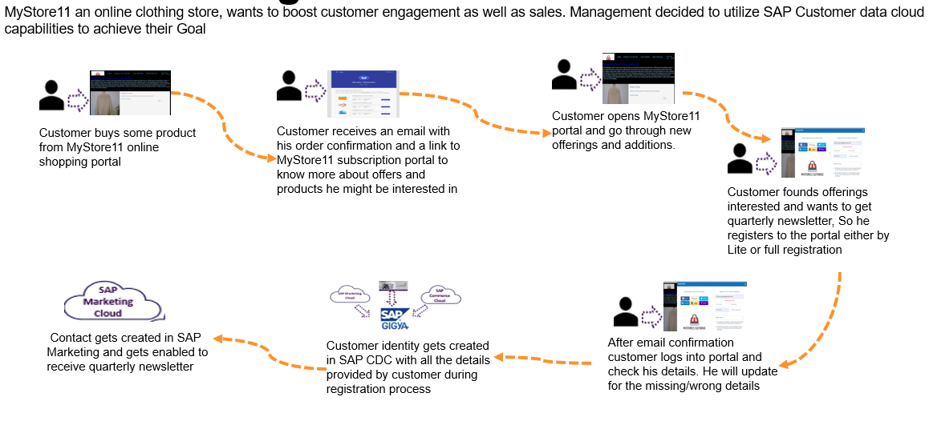

## High level requirements

Below are the high-level requirements for this scenario:

Company portal is created in SCP for customer onboarding with option to login, register and edit profile

Registration-as-a-service (RAAS) service of Customer Data Cloud is used to embed the registration and login screens to the portal. Option for both lite and full registration is provided

Social plugins are used for quick registration and login

After successful login customer will be prompted to provide more details for progressive profiling

Subscription and consent management is maintained

The customer data from CDC will be sent to SAP Marketing via CPI to create contacts which will then be used for campaign

Policies have been defined for the password complexity and captcha

## Key Value Drivers for the Business Process

Solution brings the following values to business:

It helps to identify and engage customers across channels and devices

SAP customer identity provides seamless and secure access to customers through registration and social login screens. It gathers valuable data based on permission to drive more personalized

customer experience while protecting their personal data

It builds more trusted and valued relationship with customers

It securely identifies online visitors from any touchpoint

It provides benefit of specialized protection against account takeover and DDoS attacks

It turns unknown online visitors into known and loyal customers

## Leading Practice Inputs

This scenario is related to Living Marketing of Golden Template

Higher Customer Lifetime Value: SAP CDC provides customers with easy to register tools with permission and consent based profiling

Higher Revenue: SAP CDC helps to increase revenue by converting general site visitors to loyal customers

# Business Sub-Process Description

The process defines how customer can control his profile and personal information based on consent based profiling. Once customer registers on portal or registered customer updates his profile with some additional information or subscription option, in/out information immediately flow to SAP CDC. Updated data in SAP marketing system can be further utilized in dynamic segmentation.

## Business Sub-Process diagram

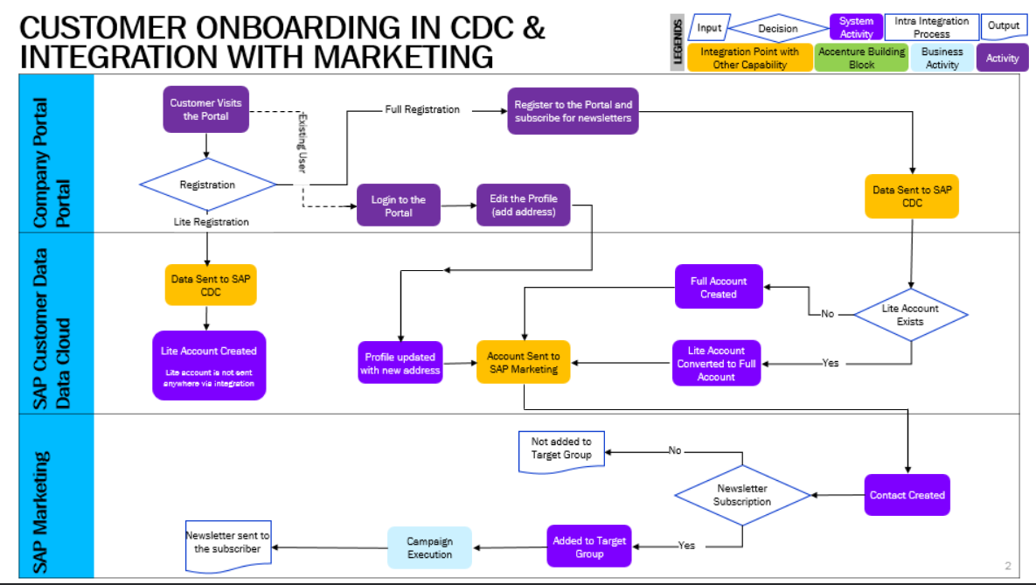

# Sub Process Activities

**Customer visits portal and completes his registration or update his existing account**

Customer visits the portal and subscribe for newsletters for promotional offers and complete registration by providing minimal mandatory information along with subscription.

**Check new account in SAP customer data cloud**

SAP CDC consultant will login to CDC system and check the newly created account for all the details or the updated details for existing accounts which will be available under identity access with timestamp.

**Check new account in SAP marketing and start segmentation**

Business manager from marketing team will login to system and check the updated contact list with required information e.g; subscription and location (address) etc. He then can perform segmentation of contacts and create campaign in marketing system.

## Activity List

It maps to the BP317, Activity definition document if applicable for the project & also has references in the process/sub process diagram.

|  |  |  |  |  |
| --- | --- | --- | --- | --- |
| Name | Description | Transaction Code,  if relevant | Roles involved | Regulatory /Other Controls |
| Customer Registration/Update | Customer registration/updation on portal | N/A | Customer | N/A |
| Check for new accounts and update in SAP CDC | SAP CDC consultant will login and checks for new updated | N/A | SAP CDC admin | N/A |
| Segmentation and Campaign | Create the segmentation model and campaign to send newsletter | N/A | Marketing admin | N/A |

## Inbound Communication

The Inbound Communication needs to be specifically documented for the client specific situation, like interfacing with external systems, workflow, form & Medium of communication.

|  |  |  |  |  |
| --- | --- | --- | --- | --- |
| Activity | Type (email, form, handoff, etc) | Automatic/Manual | Source | Description |
| Receive Customer registration data | Data | Automatic | Company Portal | Receive customer light and full registration data from company portal to CDC |
|  |  |  |  |  |
|  |  |  |  |  |
|  |  |  |  |  |
|  |  |  |  |  |

## Outbound Communication

The Outbound Communication needs to be specifically documented for the client specific situation, like interfacing with external systems, workflow, form & Medium of communication.

|  |  |  |  |  |
| --- | --- | --- | --- | --- |
| Activity | Type (email, form, handoff, etc) | Automatic/Manual | Source | Description |
| Customer notification | Email | Automatic | CDC | Email account verification mail |
| Customer notification | Email | Automatic | CDC | Welcome email |

## 

## Test Conditions

This section captures Test conditions for this sub process for the any specific client requirements. Generic test conditions for this sub process will be within the AAES test scripts.

|  |  |  |
| --- | --- | --- |
| Number | Test Condition – Action | Expected Result |
| 1 | Available under test script document | TE586_C4C_Onboarding of Customers in CDC and integration with Hybris Marketing |
|  |  |  |

# Sub-Process Variation

## Business Unit Led

N/A

## Geography/Legal Entity Led

N/A

# Role Definition & Organisational Impact

The content in this section will serve as input for the training and performance support team’s deliverables.

## Role/Skill Class Inventory

|  |  |  |
| --- | --- | --- |
| Role | Skills | Knowledge |
| Administrator | SAP CDC | Basic config knowledge |
| Administrator | SAP CPI | Basic config knowledge |
| Administrator | SAP Marketing | Basic config and segmentation, campaign management |

## Role Summary

|  |  |  |
| --- | --- | --- |
| Role | List of Steps | SAP Transaction |
| N/A | N/A | N/A |
|  |  |  |

## 

## Organizational Impact

|  |  |  |  |  |
| --- | --- | --- | --- | --- |
| Reference # | Impact Description | Impact (H/M/L) | Impact Type | Impacted Groups |
| N/A | N/A | N/A | N/A | N/A |

# 

# Process Fitness & Gap Analysis

## Process Fitness

|  |  |  |  |  |
| --- | --- | --- | --- | --- |
| Req ID | Short Description | Long Description | Req. Type | Accenture Reusable Assets |
| N/A | N/A | N/A | N/A | N/A |
|  |  |  |  |  |

## 

## Gap Analysis

|  |  |  |  |  |  |  |
| --- | --- | --- | --- | --- | --- | --- |
| Country/ Region/ Business Impacted | Gap Description | Legal Req. (Y/N) | Magnitude of Impact (L/M/H) | Solution Type | RICEFW No. | Ref. to Req. id. |
| N/A | N/A | N/A | N/A | N/A | N/A | N/A |
|  |  |  |  |  |  |  |

# RICEFW

## Reports

|  |  |  |  |  |  |
| --- | --- | --- | --- | --- | --- |
| Client XYZ  RICEFW # | Report Description | Complexity (H/M/L) | Comments | Use from myConcerto/ARTL (New/Rework/Rep) | Ref # from RICEFW inventory |
| N/A | N/A | N/A | N/A | N/A | N/A |
|  |  |  |  |  |  |

## Interfaces (Inbound / Outbound)

|  |  |  |  |  |  |
| --- | --- | --- | --- | --- | --- |
| Client XYZ  RICEFW # | Interface Description | Complexity  (H/M/L) | Comments | Use from myConcerto/ARTL (New/Rework/Rep) | Ref # from RICEFW inventory |
| N/A | N/A | N/A | N/A | N/A | N/A |
|  |  |  |  |  |  |

## 

## Conversions

|  |  |  |  |  |  |
| --- | --- | --- | --- | --- | --- |
| Client XYZ  RICEFW # | Conversion Description | Complexity  (H/M/L) | Comments | Use from myConcerto/ARTL (New/Rework/Rep) | Ref # from RICEFW inventory |
| N/A | N/A | N/A | N/A | N/A | N/A |
|  |  |  |  |  |  |

## 

## Enhancements

|  |  |  |  |  |  |
| --- | --- | --- | --- | --- | --- |
| Client XYZ  RICEFW # | Enhancement Description | Complexity  (H/M/L) | Comments | Use from myConcerto/ARTL (New/Rework/Rep) | Ref # from RICEFW inventory |
| N/A | N/A | N/A | N/A | N/A | N/A |
|  |  |  |  |  |  |

## 

## Forms

|  |  |  |  |  |  |
| --- | --- | --- | --- | --- | --- |
| Client XYZ RICEFW # | Form Description | Complexity (H/M/L) | Comments | Use from myConcerto ARTL (New/Rework/Rep) | Ref # from RICEFW inventory |
| N/A | N/A | N/A | N/A | N/A | N/A |
|  |  |  |  |  |  |

## 

## Workflows

|  |  |  |  |  |  |
| --- | --- | --- | --- | --- | --- |
| Client XYZ RICEFW # | Workflow Description | Complexity (H/M/L) | Comments | Use from myConcerto (New/Rework/Rep) | Ref # from RICEFW inventory |
| N/A | N/A | N/A | N/A | N/A | N/A |
|  |  |  |  |  |  |

# Integration Points

SAP CDC is integrated with SAP Marketing to create/update as contact in SAP Hybris Marketing as and when an account is created/updated in SAP CDC

## Integration Issues

|  |  |  |  |  |
| --- | --- | --- | --- | --- |
| Issue # | Issue Description | Impact | Status | Resolution |
| N/A | N/A | N/A | N/A | N/A |
|  |  |  |  |  |

## Other issues

|  |  |  |  |  |
| --- | --- | --- | --- | --- |
| Issue # | Issue Description | Impact | Status | Resolution |
| N/A | N/A | N/A | N/A | N/A |
|  |  |  |  |  |

#### Revision History

|  |  |  |  |
| --- | --- | --- | --- |
| Date | Version | Description | Author |
| 21.01.2019 | V1.0 | Business Sub-Process Design Document  Customer Onboarding in CDC and Integration with Marketing | Praveen/Gaurav |
| 17.03.2020 | V1.1 | Updated document as per new template | Praveen Dadhich |
|  |  |  |  |